Define the Problem Statement
Incident Lifecycle Automation in ServiceNow

1. Background
Incident management is an important IT Service Management (ITSM) process. When a user experiences a service interruption or technical issue, the support team needs to record the incident, assess its priority, assign responsibility, investigate the cause, communicate progress, and document the resolution.

2. Problem statement
Incident handling can become slow or inconsistent when key steps—such as categorisation, prioritisation, assignment, status communication, and resolution documentation—depend on manual effort or are not followed consistently. This can make it harder for support teams to track ownership, reuse existing solutions, and provide users with timely updates.

3. Project goal
The goal of this project is to design and configure a ServiceNow-based approach for supporting a consistent incident lifecycle, from incident creation through investigation, resolution, and closure. Where appropriate and supported by the project configuration, workflow automation can help standardise selected steps and reduce repetitive manual work.

4. Objectives
Define a consistent incident lifecycle and the information needed at each stage.
Identify opportunities to use ServiceNow Flow Designer and Business Rules for suitable workflow tasks.
Clarify how incidents are categorised, prioritised, assigned, tracked, resolved, and closed.
Identify how Knowledge Management can help technicians find reusable solutions.
Describe how Change Management may be involved when an incident requires a controlled system change.
Define test scenarios that can be used to check whether the configured process behaves as intended.

5. Scope
- In scope: incident lifecycle analysis; incident record fields and states; assignment and priority approach; selected automation opportunities; knowledge article use; resolution and closure information; test scenarios and demonstration.
- Related process: Change Management is considered when a resolution requires a controlled change. Incident and change records should follow the organisation's applicable process.
- Out of scope unless separately approved: integrations with external monitoring tools, custom predictive AI, production deployment, and claims of measured business improvement without test evidence.

6. Stakeholders and users
- End users — report issues and need understandable status updates.
- Service desk / support agents — record, categorise, prioritise, assign, investigate, and resolve incidents.
- Support groups — receive assigned work and provide technical resolution.
- ServiceNow administrator / developer — configures and tests platform behaviour within authorised access.
- Service owner or project reviewer — checks whether the proposed process meets its intended requirements.

7. Expected outcome
A documented and demonstrable ServiceNow incident management process with clearly defined lifecycle steps and appropriately selected automation. Any claimed reduction in resolution time or recurring incidents should be supported by measured results; otherwise, it should be described as an intended benefit rather than a proven outcome.

8. Problem statement summary
- How might ServiceNow be configured to make incident handling more consistent and traceable, reduce repetitive manual steps, improve the use of existing knowledge, and support timely resolution from incident creation to closure?

Process Diagram
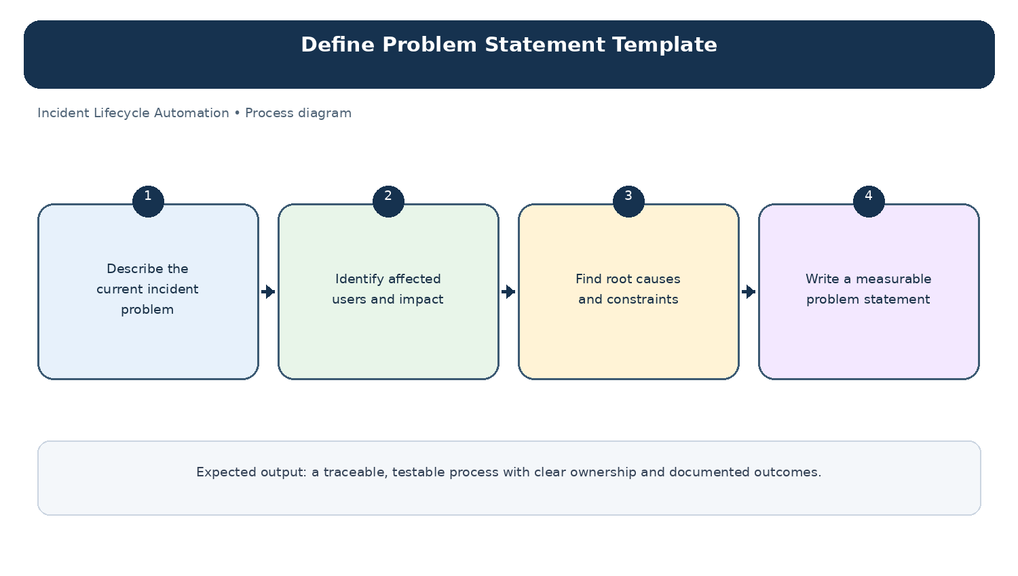
Diagram: Define Problem Statement Template — project-specific process overview.

